Brand Website
- Add Warehouse Link on Main Menu.
Warehouse Landing Page
- In lieu of grid when user initially access Warehouse – customizable by Brand. HTML link will be provided by Brand.
- What is the current functionality of the Home button? Based on above change – take user back to Landing page
- If user selects Home Page – collapse Category Tree
Company Selection
- If multiple Company for user then as a First time user we prompt a pop-up screen for Company selection.
- This pop up screen should contain a drop down menu with a Data Entry field along with scroll down – As user types in text we filter and take user to that part of the list. List companies in alphabetical order. Ex – User types in C we automatically take the user to the first entry starting with “C”. User enters Co – we automatically take user to the first entry starting with “Co”.
- After user shops for the first time – remember the last company selection and default to that company upon next user login.
- User can still change company on current Warehouse page with current drop down
Search Results
- QTY column – up/down arrows are to be removed
- Once the rep positions the cursor in the QTY column, the number 0 is automatically highlighted, so the rep can input desired quantity without having to highlight the 0 themselves. So the “0” is highlighted and the rep types “5” – then “5” will show in QTY field. Right now if they put a cursor in that field and type 5 – the quantity will be “50”.
- “Add to Cart” column to be removed
- Add an “Add To Cart” button at the top of the page. The user will just use the “Add to Cart” button that will be on top as well as the bottom of the page.
- Delete “Search” label
- Move “Search” button to the right of the search box
- SKU column is to accommodate SKUs that are up to 15 characters long (Penn Barry will use these long SKUs only). When user is identified as Penn Barry, and as needed, then eliminate the description column and resize the SKU column to show entire SKU. If the Brand is any other than Penn Barry then leave the Description column visible and resize SKU column for 5 characters.
- “In Stock” column label is renamed to [default warehouse] Stock. Originally it will be “Tarboro Stock” – The title of this column is to be wrapped and appear on 2 lines) so the word “Tarboro” will appear above the word “Stock”. With this we are going to 2 line column headers.
- “QTY” column label is renamed to “Order QTY”, again on 2 lines, so “Order” appears over “QTY” to save on space.
- “Multi Warehouse” column label is renamed to “Additional Stock”, again on 2 lines, so “Additional” appears over “Stock”.
- Grid Label “Products – Warehouse: Tarboro, NC” – remove Tarboro, NC and bring back a drop down for a selection of Warehouse. This is to allow the user to change the Display Warehouse QTY without having to change their Default Warehouse under “My Account”.
- Warehouse Default is still utilized every time the user access warehouse from Brand website.
- “Categories” label above the drill down menu is renamed to “Product Categories”.
- Above the “Add to Cart” button on top, there will be new 2 buttons: “View Cart” and “Check Out”, both on 2 lines labels. To the left remain with: “Your Cart:” and display (as today) “empty” if it is empty, or “Items: 3 Total: $120”
- Based on removing column, placing column titles in two lines (wrapped) and removing the QTY up/down arrows – if we have room left over - extend the Drill Down Tree and search panel on the right hand side.
- ASC reiterates that as the user clicks on the titles in the Drill Down Tree, we should show the full name as a hover over.
- ASC reiterates that as the user hovers over the “i” for the details screen – they would prefer this to be a hover over screen rather than a pop-up screen.
- If QTY is 0 and user selects to “Add To Cart” pop up warning message that no QTY has been indicated.
- Auto adjusts the screen for higher resolutions, so that the screen will take more space for resolutions above 1024x768, for example for 1280x1024, if possible.
- At 1024x768 resolution, with many products showing, there are currently 2 scrollers – one for the browser (outside scroller) and for the product list (inside scroller). Brands want to have a single (outside) scroller, so that when there are many products showing, the screen drops down as much as needed and the rep can scroll with that one scroller down as much as needed to get to the rest of the products (those that do not show on the first page, but show on the 2nd page and further down). In this way the length of the screen will “auto adjust” based on the number of products showing as a result of the search.
Detail Screen
- Display in the following order 1) SKU 2) Price and 3) Config (Of course description will still be located below the image)
- Extended the page (width) to accommodate the Configuration string as it can be up to 50 characters long. No wrapping.
- Description contains quotation marks (“) at the beginning and end of description. ASC indicated that if we use the DLL to populate the description rather than the spreadsheet then we should not have these quotations displayed.
Multi Warehouse Screen
- Top bar to display 1) SKU and then 2) Model listed
- Remove up/down arrows in QTY fields
- Automatically highlight QTY of 0 when user clicks on field

Shopping Cart

- Allow for user to delete entry by line item, by Warehouse and Entire Cart.
- Cart Overview – add Columns for each Warehouse QTY rather than just a total warehouse QTY. Example – Tarboro QTY for line item 1, Sunnyvale QTY for line item one. Total QTY for line item one. If no items are being shipped from a particular Warehouse then do not show a column with that Warehouse listed. That is if all QTY for that warehouse is 0; then do not show that column.
- Remove QTY Exist column

Check Out – Multi Warehouse

- Upon confirming inventory during check out – if QTY no longer exists in current warehouse selected but does exist in another warehouse – provide a message to customer indicating such and list the Warehouse(s) where Item does exist with Qty > than 0.
- User can only select one Shipping Type per order
- If any single Warehouse has a shipment over 150 lbs then we calculate LTL and all other FedEx options for all Warehouses included in the order.
- Display Total shipping cost by warehouse and by shipping type
- Display Total shipping totaling all warehouse by shipping type

Shipping Type | WH 1 | WH 2 | Total
Overnight | $20 | $10 | $30
2nd Day Air | $50 | $35 | $85
LTL | $100 | $139 | $115

Affilia

- We agreed to review the difference between their DLL and our DLL to understand the issue we had with theirs.
- We agreed to send Richard the latest database

ASC

- VPN Access
- Need Server to install application
- Finalize what options are to be available based on list provided - (insurance, delivery type, special services, etc.)
- Provide final dimensions and formula for Shipping Weight
- Provide updated Order XML – based on shipping specialties to be available.

Warehouse Example Image

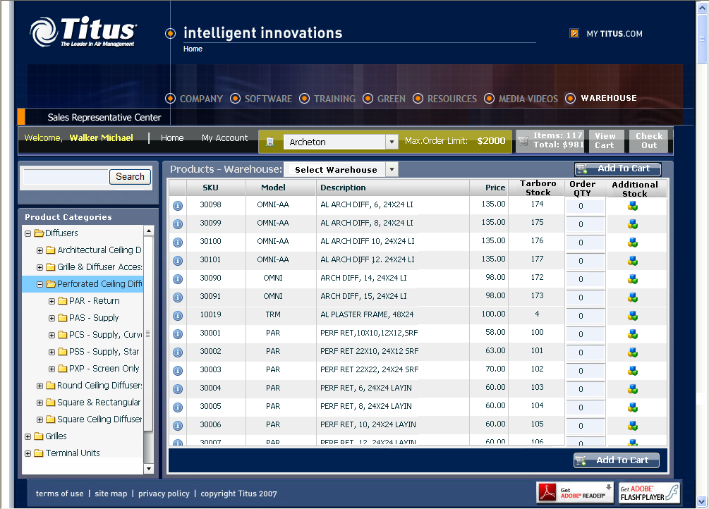

Detail Image Multi Warehouse Image

